38.71: a) Largest wavelength shift:
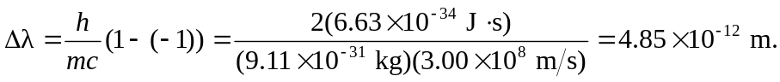
b) We want 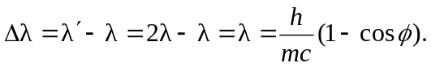
Smallest energy implies largest 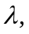so

